ACKNOWLEDGEMETS
The satisfaction and euphoria that accompany the successful completion of any task would be incomplete without the mention of people who made it possible, whose constant guidance and encouragement crowned our efforts with success. It is a pleasant aspect that we have now the opportunity to express my gratitude for all of them.
I wish to convey my special thanks to Dr. A.V.L.N. Sujith, Head of Computer Science and Engineering in Narsimha Reddy Engineering College, for giving the required information in doing my internship. Not to forget, we thank all other faculty and non-teaching staff, and my friends who had directly or indirectly helped and supported me in completing my project in time.
I am very much thankful to Dr. P Lokanatham, Principal of Narsimha Reddy Engineering College for his kind support and for providing necessary facilities to carry out the internship within the college.
I also express my gratitude to the my supervisor Dr. RamaSubba Reddy, for helping me with the queries regarding internship.
It is with immense pleasure that we would like to express my indebted gratitude to my trainer Mr.B. Lokesh, Data Analyst Value-Laden Solutions who has guided me a lot and encouraged me in every step of the internship. I thank her/him for the stimulating guidance, constant encouragement and constructive criticism which have made possible to bring out this internship.

ABSTRACT
Loan approval is a complex decision-making process that involves assessing an applicant's creditworthiness and ability to repay the loan. Banks and other financial institutions use a variety of factors to evaluate loan applications, including credit history, income, debt-to-income ratio, and employment history. The goal of the loan approval process is to identify borrowers who are likely to repay their loans and minimize the risk of default.In recent years, there has been a growing interest in using machine learning (ML) to improve the accuracy and efficiency of the loan approval process. ML algorithms can be trained on large datasets of historical loan applications to learn patterns and relationships that can be used to predict future loan outcomes. This information can then be used to develop predictive models that can identify borrowers who are at a high risk of default.
The use of ML in loan approval has several potential benefits. First, ML models can be more accurate than traditional methods of credit scoring. Second, ML models can be more efficient, as they can automate many of the tasks involved in the loan approval process. Third, ML models can be more flexible, as they can be updated with new data as it becomes available.Banks are making major part of profits through loans. Though lot of people are applying for loans. It’s hard to select the genuine applicant, who will repay the loan. While doing the process manually, lot of misconception may happen to select the genuine applicant. Therefore we are developing loan prediction system using machine learning, so the system automatically selects the eligible candidates. This is helpful to both bank staff and applicant. The time period for the sanction of loan will be drastically reduced. In this paper we are predicting the loan data by using some machine learning algorithms .
KEYWORDS: Loan approval prediction , loan status, education , random forest, matplotlib, seaborn.

CONTENTS

CH NO | CHAPTER NAME | PG NO
1 | Introduction  1.1Problem  1.2Research question  1.3Purpose  1.4Goals | 5  6  7  7  7
2 | Literature Review  2.1 Loan Approval Technic  2.2 Loan Approval Prediction | 8  8  11  13
3 | Technologies used  3.1 Machine learning algorithm  3.2 Random forest algorithm  3.3 Matplotlib  3.4 Bar graph  3.5 Pie chart using matplotlib  3.6 Box plot using matplotlib  3.7 Histogram using matplotlib  3.8 Line plot and sub plot using matplotlib  3.9 Scatter plot using matplotlib  3.10 Seaborn  3.11 Plot types in seaborn  3.12 Numpy | 15  15  18  19  19  20  21  21  22  22  23  23
4 | Coding  4.1 import necessary libraries  4.2 Load the data set  4.3 Check for missing value  4.4 Plotting  4.5 Data Preprocessing  4.6 Train random forest Classifier  4.7 Prediction  4.8 Evaluate the model | 26  26  26  27  27  29  29  30  30
5 | 5.1 ScreenShot’s & Output’s | 32
6 | Conclusion | 39
7 | Bibliography | 41

LIST OF FIGURES

FIG No: | FIGURES: | Pg No:
1 | Decision tree | 14
2 | Random forest | 16
3 | Bar graph | 18
4 | Pie chart | 19
5 | Box plot | 20
6 | Histogram | 21
7 | Sub plot | 22
8 | Scatter plot | 23
9 | Violin plot | 25
10 | Heat map | 26
11 | Pair plot | 27
12 | Predicting | 28
13 | Data sets | 37
14 | Bar Graph plot | 38
15 | Bar diagram | 39
16 | Bar diagram | 39
17 | Pair plot | 40
18 | Pain plot | 40
19 | Accurarcy | 41
20 | Confusion matirx | 41
21 | Matrix | 42
22 | Report | 43

CHAPTER 1
INTRODUCTION
In today's dynamic financial landscape, loan approval remains a critical decision for banks and other lending institutions. Accurately assessing an applicant's creditworthiness and repayment capacity is essential to minimize the risk of defaults and maintain financial stability. Traditionally, loan approval processes have relied on manual evaluations and subjective decision-making, often leading to inconsistencies and inefficiencies.
However, the advent of machine learning (ML) has revolutionized the realm of loan approval prediction. ML algorithms can analyze vast amounts of historical loan data, identifying patterns and relationships that can effectively predict the likelihood of future loan repayment. By leveraging ML, financial institutions can gain valuable insights into borrower behavior, enabling them to make informed decisions that enhance the loan approval process.
ML algorithms possess the remarkable ability to analyze vast amounts of historical loan data, identifying patterns, relationships, and subtle nuances that traditional methods may overlook. By harnessing the power of ML, financial institutions can gain valuable insights into borrower behavior, enabling them to make more accurate and objective predictions of loan repayment likelihood. Traditionally, banks use rule-based fraud detection systems. These systems are manually maintained and rely on rules created by employees of the bank. This process is time-consuming and may not be able to identify com- plex relationships in the data. But with the increasing popularity of artificial intelligence and statistical modeling, there is now a possibility to use various machine learning models to detect fraudulent payments.
Data Quality: The effectiveness of ML models hinges on the quality and comprehensiveness of the data used for training. Ensuring data accuracy, consistency, and relevance is crucial for reliable predictions and informed decision-making.
Model Explainability: ML models can sometimes be opaque, making it difficult to understand the rationale behind their predictions. This can hinder transparency and trust in the decision-making process. Interpretable ML techniques can address this issue, providing explanations for model predictions and fostering transparency.
Fairness and Bias: ML models can inadvertently perpetuate biases present in the training data. Careful data curation, bias mitigation techniques, and ongoing monitoring are essential to prevent discriminatory outcomes and ensure fair and equitable access to financial services.
Overfitting and Generalizability: Overfitting occurs when a model is too closely tailored to the training data, leading to poor performance on unseen data. Generalizability is crucial for ensuring that the model can accurately predict loan outcomes in real-world scenarios. Regular evaluation and refinement of the model are essential to maintain generalizability and effectiveness.
Continuous Monitoring and Maintenance: ML models require ongoing monitoring and maintenance to ensure their effectiveness in the face of changing market conditions, borrower behavior, and regulatory requirements. Continuous evaluation and adaptation are key to maintaining the relevance and accuracy of ML-powered loan approval prediction systems.
In the dynamic landscape of financial services, the accurate and efficient approval of loans plays a pivotal role in ensuring economic growth and financial stability. Traditional methods of evaluating loan applications often rely on historical data and predetermined criteria, leading to delays, inefficiencies, and potential biases.
. In recent years, the integration of advanced technologies and predictive modeling techniques has emerged as a transformative solution for optimizing the loan approval process.
This study delves into the realm of predictive modeling for loan approval, leveraging cutting-edge data analytics and machine learning algorithms to enhance decision-making in the lending domain. The objective is to develop a robust and adaptive system capable of assessing the creditworthiness of applicants with greater precision, speed, and fairness.
The significance of this research lies in its potential to revolutionize the way financial institutions evaluate loan applications. By harnessing the power of predictive analytics, lenders can not only streamline their approval processes but also mitigate risks associated with lending by identifying patterns and factors that may go unnoticed through traditional methods.
However, the advent of machine learning (ML) has revolutionized the realm of loan approval prediction. ML algorithms can analyze vast amounts of historical loan data, identifying patterns and relationships that can effectively predict the likelihood of future loan repayment. By leveraging ML, financial institutions can gain valuable insights into borrower behavior, enabling them to make informed decisions that enhance the loan approval process.
.
1.2 Research question
These research questions address the intersection of IT and loan approval prediction, exploring how technology can be leveraged to enhance the efficiency, security, and transparency of the loan approval process. Depending on your specific interests and objectives, you may further refine or expand upon these questions.
1.3 Purpose
Predicting loan approval helps financial institutions assess the risk associated with lending money to an individual or a business. the purpose of loan approval prediction is

1.4 Goals
The goal of a loan approval prediction project is to develop a predictive model that assesses the likelihood of loan approval for applicants based on historical data and relevant features.
- Identify and assess the risk associated with loan applicants to minimize the likelihood of defaults and financial losses
- Enable financial institutions to make more accurate and efficient decisions regarding loan approvals.

CHAPTER 2
LITERATURE REVIEW
2.1 LOAN APPROVAL TECHNIC
Today, most of the banks are focusing on online methods to do away with the complex documentation procedures and to accelerate the entire loan approval process. Also, the demand for such loans is higher these days. Typically, a Personal loan approval involves the following steps:
- Loan application
- Discussion with the lender
- Background verification by the bank
- Signing in of necessary documents
- Loan sanctioning and disbursement
Processing of Loan Application
Ideally, banks should acknowledge the receipt of a loan application within 7 days from the date of request. After the basic examination of the details furnished by the applicant, banks should intimate the person and issue him a registration number. Further documents to be submitted for loan approval should also be mentioned in the intimation letter. In cases where initial application fails to meet the eligibility criteria, the lender organization must return the application and communicate the reason for rejection. Banks also check your CIBIL report for written-off loans, payment history details, and EMI-income ratio to determine your eligibility.
Approval of a Loan
The time taken for approval of a personal loan depends on the authenticity of the information provided by you. On approval, borrowers may either be offered a fixed rate of interest on the loans or a floating rate. Floating rates change according to the fluctuations in market. For the bank to approve loan request, you will have to submit the following documents:
- Bank statement
- Identity proof and address proof
- Salary statement
- Income tax statement
It is advisable that you maintain a decent credit history to smoothen the entire process of loan approval. Paying dues at the right intervals and reviewing your credit status from time to time will help you in improving your scores. Before applying for loan, you can also check your eligibility through the loans webpage of the respective bank. You just have to fill out some basic information to know whether you are eligible for a particular loan or not.
2.2 LOAN APPROVAL PREDICTION
A large majority of losses from card fraud is borne by owners of the cards. Banks are only liable for a small proportion of losses. They may need to compensate a client when bank employees do not manage to block a lost card properly or in some cases when the law tells them to do so. These losses may not be a large enough incentive for banks to detect and prevent frauds. But they face a risk of a damaged reputation if they do not prevent frauds and clients start losing large amounts of money. This is why banks and card associations are actively trying to detect and prevent fraudulent transactions. These measures apply not only to card transactions but also to money transfers from one account to another and other types of transactions. For this task banks use various systems which monitor all transactions made by customers and look for potentially fraudulent transactions. These systems can either be rule-based or use some kind of machine learning method for fraud detection.
Traditional processes determine the risk by manually looking at the applicant's income, credit history, and several other dynamic parameters and creating a data-driven risk model. Despite using data science in this process, there is still a large amount of manual work involved. Researchers have recently explored the possibility of using deep learning in various aspects of this process. For example, credit score and credit history are essential parameters for assessing the applicant's lending risk. DL-based approaches such as Embedding Transactional Recurrent Neural Network (E.T.-RNN) compute the credit scores of applicants by looking at the history of their credit and debit card transactions. Such an approach eliminates the high dependency on manual intervention, extensive domain knowledge, and human bias in loan approval prediction.
Till now loans are processed by various banks through pen and paperwork. When the large no of customers’ apply for bank loan these bank take lot of time to approve thei rloan. After approval of loan by the banks, there is no surety that the chosen applicant is capable of paying loan or not. Many banks use their own software’s for the loan approval. In existing system we use datamining algorithms for the loan approval; this is the old technique for the approval of loan. Mutiple data sets are combined and form a Generalised datasets, and different machine learning algorithms are applied to generate
results. But these techniques are not up to the mark. Duet o this huge banks are suffering from financial crises. To resolve this issue we introduce a new way for approval of
loans.
Loan sanctioning and credit scoring forms a multi-billion dollar industry -- in the US alone. With everyone from young students, entrepreneurs, and multi-million dollar companies turning to banks to seek financial support for their ventures, processing these applications creates a complex and cumbersome task for any banking institution. As of 2022, more than 20 million people in the US have active loans owing a collective debt of 178 billion dollars. Despite that, more than 20% of all applicants were denied loans. The loan approval or rejection has enormous ramifications for both the applicant and the bank, causing possible opportunity costs for both parties. Banks like Wells Fargo and Morgan Stanley have looked at the use of AI in determining lending risk and developing a loan prediction system in recent years to overcome human bias and delays in the application processing time.
Loan Approval System is software used for approval of loan in banking sector. In this proposed system we have used machine learning algorithm. Machine Learning is process in which a symmetric model is build from theexisting dataset; this model is applied for the testing of the new dataset. The system consists of trained dataset and test dataset. The trained dataset is used for construction of model. This model is applied on testing dataset for the required result.
CHAPTER 3
TECHNOLOGIES USED
3.1 MACHINE LEARNING ALGORITHMS
Machine learning algorithms are computational models that enable machines, particularly computers, to learn from data and make predictions or decisions without being explicitly programmed. These algorithms utilize statistical techniques to recognize patterns, learn from experience, and improve their performance over time as they are exposed to more data.
3.2 RANDOM FOREST ALGORITHM
The Random Forest Classifier is an ensemble learning algorithm that belongs to the family of decision tree-based algorithms. It is widely used for both classification and regression tasks. Random Forests build multiple decision trees during training and merge their predictions to provide a more accurate and stable result.
The random forest algorithm is made up of a collection of decision trees, and each tree in the ensemble is comprised of a data sample drawn from a training set with replacement, called the bootstrap sample. Of that training sample, one-third of it is set aside as test data, known as the out-of-bag (oob) sample, which we’ll come back to later. Another instance of randomness is then injected through feature bagging, adding more diversity to the dataset and reducing the correlation among decision trees. Depending on the type of problem, the determination of the prediction will vary. For a regression task, the individual decision trees will be averaged, and for a classification task, a majority vote—i.e. the most frequent categorical variable—will yield the predicted class. Finally, the oob sample is then used for cross-validation, finalizing that prediction. . It is widely used for both classification and regression tasks. Random Forests build multiple decision trees during training and merge their predictions to provide a more accurate and stable result.

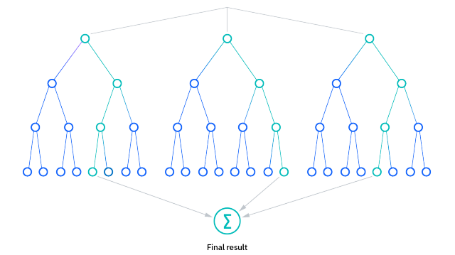
Fig3.2.1. Decision Tree

The key steps involved in the Random Forest algorithms:
- RANDOM SAMPLING: Randomly select subsets of the training data (with replacement) to train each tree. This process is known as bootstrap sampling.
- RANDOM FEATURE SELECTION: For each tree, randomly select a subset of features at each split point during the construction of the tree. This helps in creating diverse trees and reduces overfitting.
- DECISION TREE CONSTRUCTION: Construct a decision tree for each subset of data using the selected features. The tree is grown until a stopping criterion is met, such as a maximum depth or the number of data points in a leaf.
- VOTING(CLASSIFICATION) OR AVERAGING(EGRESSION): For a new input, each tree in the forest predicts an outcome. In the case of classification, the class that receives the majority of the votes is the final prediction. For regression, the predictions are averaged to obtain the final result.

The advantages of Random Forest includes:
- ENSEMBLE LEARNING: Combining the predictions of multiple models often leads to better overall performance and generalization.
- REDUCED OVERFITTING: The randomness in feature selection and data sampling helps to reduce overfitting compared to individual decision trees.
- HIGH ACCURACY: Random Forest tends to provide high accuracy in both classification and regression tasks.
- ROBUSTNESS: It is robust to outliers and noise in the data.
- IMPLICIT FEATURE IMPORTANCE: Random Forest provides a measure of feature importance, indicating which features are more influential in making predictions.

How does Random Forest algorithm work?
Random Forest works in two-phase first is to create the random forest by combining N decision tree, and second is to make predictions for each tree created in the first phase.
The Working process can be explained in the below steps and diagram:
Step-1: Select random K data points from the training set.
Step-2: Build the decision trees associated with the selected data points (Subsets).
Step-3: Choose the number N for decision trees that you want to build.
Step-4: Repeat Step 1 & 2.
Step-5: For new data points, find the predictions of each decision tree, and assign the new data points to the category that wins the majority votes.
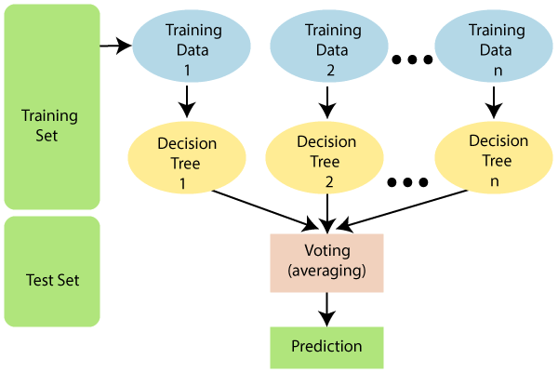
Fig 3.2.2 Random Forest
3.3 MATPLOTLIB
Matplotlib is a Python 2D plotting library which produces publication quality figures in a variety of hardcopy formats and interactive environments across platforms. Matplotlib can be used in Python scripts, the Python and IPython shells, the Jupyter notebook, web application servers, and four graphical user interface toolkits. It provides a variety of functions to visualize data and create static, animated, and interactive plots. Matplotlib is widely used for tasks ranging from simple line plots to complex visualizations.

The Visualization Design using matplotlib
- Bar Graph
- Pie Chart
- Box Plot
- Histogram
- Line Chart and Subplots
- Scatter Plot
3.4 BAR GRAPH
Bar graphs are best used when we need to compare the quantity of categorical values within the same category.Bar graphs should not be used for continuous values.
Bar graph is generated using plt.bar() in matplotlib
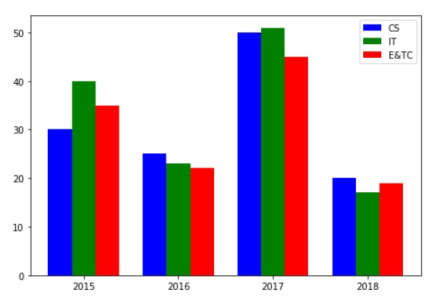
Fig 3.4.1. Bar Graph

3.5 PIE CHART USING MATPLOTLIB
A pie chart is suitable to show the proportional distribution of items within the same category. plt.pie() is used to draw the pie chart and adjust its parameters to make it more appealing.
A pie chart is rendered useless when there are a lot of items within a category. This will decrease the size of each slice and there will be no distinction between the items.
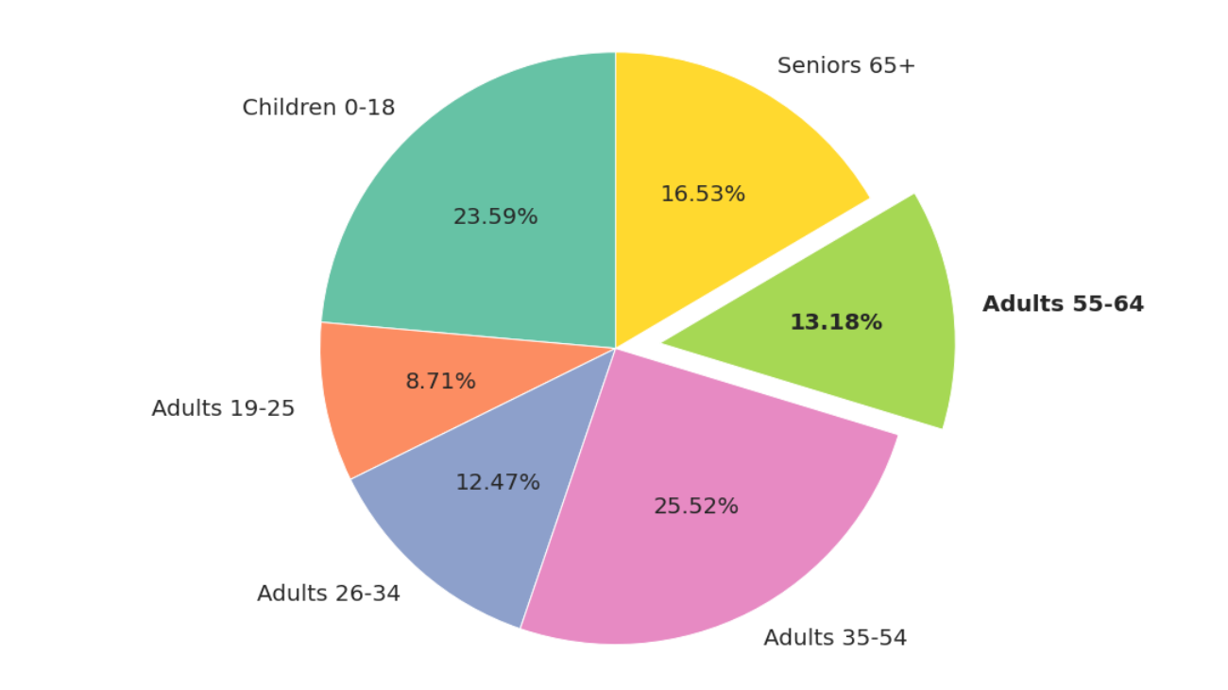
Fig 3.5.1 Pie Chart

3.6 BOX PLOT USING MATPLOTLIB

Box plot gives statistical information about the distribution of numeric data divided into different groups. It is useful for detecting outliers within each group. The lower, middle and upper part of the box represents the 25th, 50th, and 75th percentile values respectively. Box plot does not show the distribution of data points within each group.
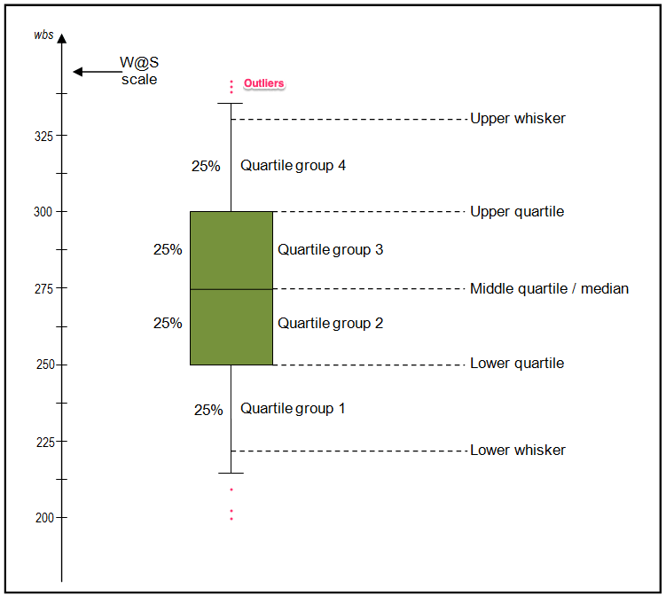
Fig 3.6.1. Box Plot

3.7 HISTOGRAM USING MATPLOTLIB
A histogram shows the distribution of numeric data through a continuous interval by segmenting data into different bins. Useful for inspecting skewness in the data. It is easy to confuse histograms with bar plots. But remember, histograms are used with continuous data whereas bar plots are used with categorical data.
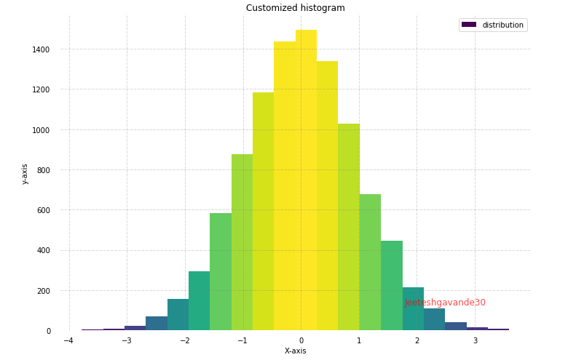
Fig 3.7.1. Histogram

3.8 LINE PLOT AND SUBPLOTS USING MATPLOTLIB
A line plot is useful for visualizing the trend in a numerical value over a continuous time interval. Matplotlib subplots makes it easy to view and compare different plots in the same figure. The plt.subplots() figure returns the figure and axes. You can provide as an input to the function how you want to display the axes within the figure. These will be adjusted using the nrows and ncols parameters. You can even adjust the size of the figure using the figsize parameter.
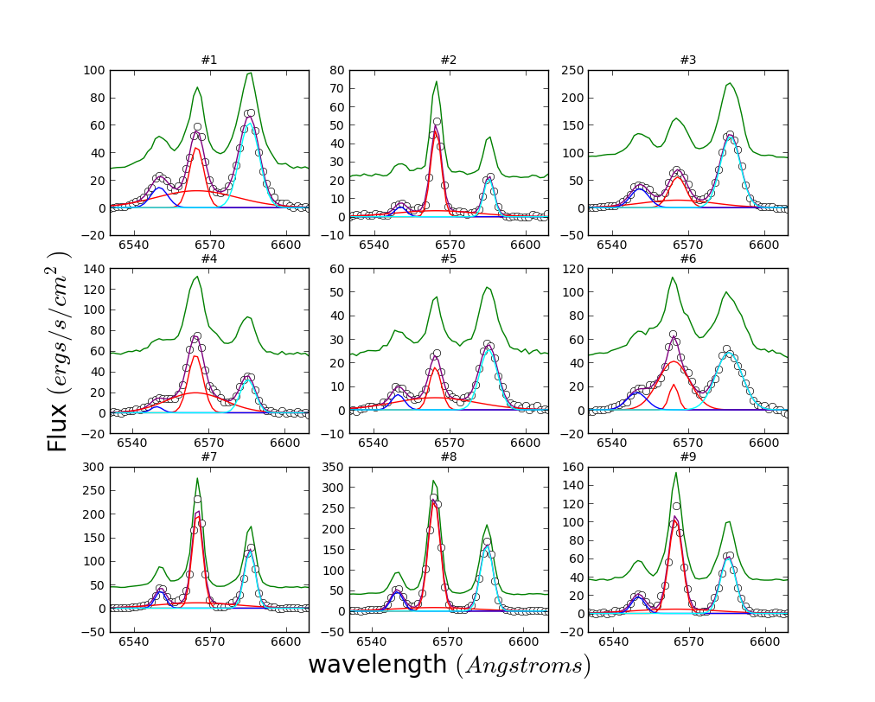
Fig 3.8.1. Subplot

3.9 SCATTER PLOT USING MATPLOTLIB

Scatter plots are useful for showing the relationship between two variables. Any correlation between variables or outliers in the data can be easily spotted using scatter plots.
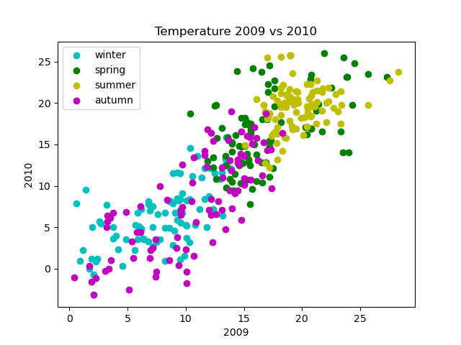
Fig 3.9.1. Scatter Plot
3.10 SEABORN
Seaborn is a statistical data visualization library based on Matplotlib. Seaborn is a powerful and flexible data visualization library in Python that offers an easy-to-use interface for creating informative and aesthetically pleasing statistical graphics. It provides a range of tools for visualizing data, including advanced statistical analysis, and makes it easy to create complex multi-plot visualizations.. Seaborn's key benefit lies in its capability to generate attractive plots with minimal coding efforts. It provides a range of default themes and color palettes, which you can easily customize to suit your preferences. Additionally, Seaborn offers a range of built-in statistical functions, allowing users to easily perform complex statistical analysis with their visualizations. Another notable feature of Seaborn is its ability to create complex multi-plot visualizations. With Seaborn, users can create grids of plots that allow for easy comparison between multiple variables or subsets of data. This makes it an ideal tool for exploratory data analysis and presentation.
3.11 PLOT TYPES IN SEABORN
- LINE PLOT: Line plots are used to visualize trends in data over time or other continuous variables. In a line plot, each data point is connected by a line, creating a smooth curve. In Seaborn, line plots can be created using the lineplot() function.
- HISTOGRAM: Histograms visualize the distribution of a continuous variable. In a histogram, the data is divided into bins and the height of each bin represents the frequency or count of data points within that bin. In Seaborn, histograms can be created using the histplot() function.
- BOX PLOT: Box plots are a type of visualization that shows the distribution of a dataset. They are commonly used to compare the distribution of one or more variables across different categories.
- VIOLIN PLOT: A violin plot is a type of data visualization that combines aspects of both box plots and density plots. It displays a density estimate of the data, usually smoothed by a kernel density estimator, along with the interquartile range (IQR) and median in a box plot-like form. The width of the violin represents the density estimate, with wider parts indicating higher density, and the IQR and median are shown as a white dot and line within the violin.
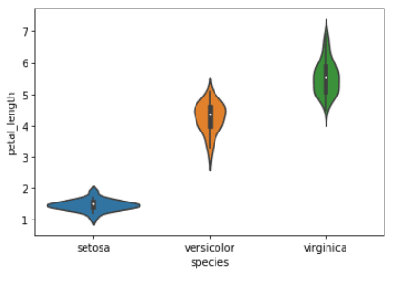
Fig 3.11.1. Violin Plot
- HEATMAP. A heatmap is a graphical representation of data that uses colors to depict the value of a variable in a two-dimensional space. Heatmaps are commonly used to visualize the correlation between different variables in a dataset.
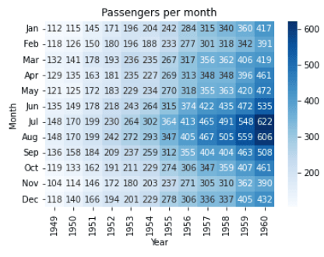
Fig 3.11.2. Heat Map
- PAIRPLOT: Pair plots are a type of visualization in which multiple pairwise scatter plots are displayed in a matrix format. Each scatter plot shows the relationship between two variables, while the diagonal plots show the distribution of the individual variables.
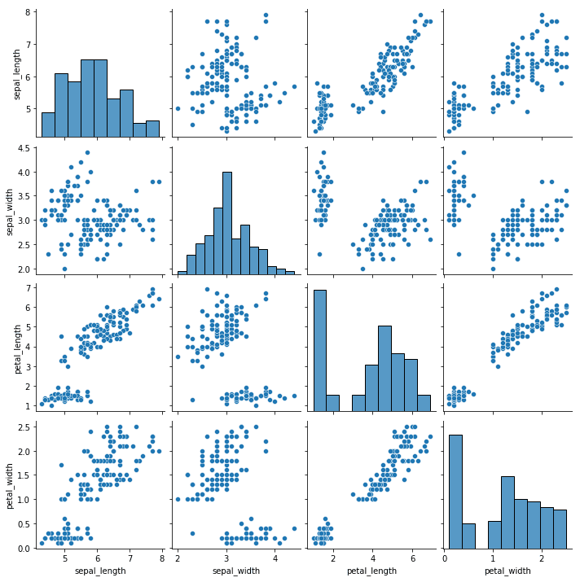
Fig 3.11.3 Pair Plot
3.12 NUMPY
NumPy (numerical Python) is a library that consists of multidimensional array objects and a set of functions for manipulating them. It’s one of the most used Python packages for scientific computing as it allows you to perform mathematical and logical operations on arrays. NumPy is a Python scripting language.

Why is NumPy used in Python?
We have lists in Python that act as arrays, however they are slow to process. NumPy aims to provide an array object that is up to 50 times faster than traditional Python lists. It may be used to conduct a wide range of array-based mathematical operations. It extends Python with advanced analytical structures that ensure fast computations with arrays and matrices, as well as a large library of high-level mathematical functions that work with these arrays and matrices. NumPy arrays, unlike lists, are kept in a single continuous location in memory, allowing programmes to access and manipulate them quickly.
Features of NumPy
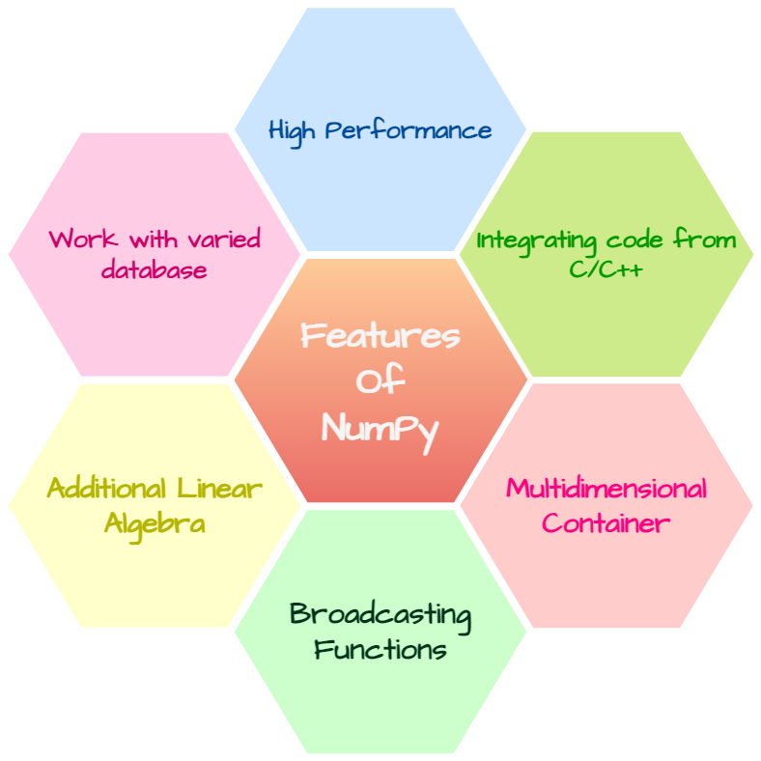
Fig 3.11.4 predicting

High performance:
NumPy addresses the slowness problem partly by providing multidimensional arrays and functions and operators that operate efficiently on arrays.
Integrating code from C/C++, Fortran:
We can use the functions in NumPy to work with code written in other languages. We can hence integrate the functionalities available in various programming languages.
Multidimensional container:
An n d array is a (usually fixed-size) multidimensional container of items of the same type and size. The number of dimensions and items in an array is defined by its shape, which is a tuple of N non-negative integers that specify the sizes of each dimension. The type of items in the array is specified by a separate data-type object (dtype), one of which is associated with each nd array.
Broadcasting Function:
The term broadcasting describes how NumPy treats arrays with different shapes during arithmetic operations. It is a very useful concept when we work with arrays of uneven shapes. It broadcasts the shape of smaller arrays according to the larger ones.
Additional linear algebra:
It has the capability to perform complex operations of the elements like linear algebra, Fourier transform, etc.
Work with varied data base:
We can work with arrays of different data types. We can use the d type function to determine the data type and hence get a clear idea about the available data set.

CHAPTER-4
CODING

4.1 IMPORT NECESSARY LIBRARIES
The import statement in a programming language, such as Python, is used to bring external libraries or modules into your code. It allows you to access and use the functions and features provided by those libraries.
import pandas as pd
import numpy as np
from sklearn.model_selection import train_test_split
from sklearn.metrics import classification_report, accuracy_score, precision_score, recall_score, f1_score, confusion_matrix
import matplotlib.pyplot as plt
import seaborn as sns
from sklearn.preprocessing import LabelEncoder
from sklearn.ensemble import RandomForestClassifier

4.2 LOAD THE DATASET
Loading a dataset is a fundamental step in data analysis and machine learning. It involves bringing external data into your programming environment, making it accessible for further exploration, analysis, and model training. Loading a dataset refers to the process of reading and importing the dataset from an external source into your programming environment. This source could be a local file on your computer, a URL, a database, or any other storage location.
df = pd.read_csv('Training Dataset.csv')

DISPLAY BASIC INFORMATION ABOUT THE DATASET
print(df.info())
DISPLAY SUMMARY STATISTICS
print(df.describe())

4.3 CHECK FOR MISSING VALUES
Checking for missing values in a dataset is an essential step in data preprocessing. Missing values can affect the accuracy of your analysis or machine learning models, and dealing with them appropriately is crucial.
print(df.isnull().sum())

Remove missing values (if any )
df_cleaned = data.dropna()

4.4 PLOTTING
Plot the Data
It visualizes the number of occurrences for each unique value in the 'Class' column, which is typically used in binary classification problems. It compares the fraud and non fraud transaction in dataset based on the column ‘class’.
plt.figure(figsize=(14,11))
plt.subplot(2,2,1)
sns.countplot(x=df['Gender'])
plt.title('distribution of Gender')

plt.subplot(2,2,2)
sns.countplot(x=df['Married'])
plt.title('distribution of Married')

plt.subplot(2,2,3)
sns.countplot(x=df['Education'])
plt.title('distribution of Education')

plt.subplot(2,2,4)
sns.countplot(x=df['Self_Employed'])
plt.title('distribution of Self_Employed')

plt.show()

PAIR PLOT OF THE DATA
sns.pairplot(df)

4.5 DATA PREPROCESSING
Data preprocessing is a crucial step in the data analysis and machine learning pipeline. It involves cleaning, transforming, and organizing raw data into a format that is suitable for analysis or model training.
X = df.drop('Loan_Status', axis=1) # Replace 'loan_approval_status' with your actual target variable
y = df['Loan_Status']

Handling categorical variables
Handling categorical variables is an essential step in the data preprocessing phase, especially when working with machine learning models. Categorical variables are those that can take on a limited, fixed number of values, often representing categories or labels. There are several techniques for handling categorical variables, and the choice depends on the nature of the data and the machine learning algorithm you plan to use. LabelEncoding involves assigning a unique numerical label to each category. This method is suitable when there is an ordinal relationship between the categories.
label_encoder = LabelEncoder()
for column in df.select_dtypes(include=['object']).columns:
df[column] = label_encoder.fit_transform(df[column])

Split the data into training and testing sets
splitting the data into training and testing sets is to simulate how well a machine learning model performs on data it has never seen before. By training the model on one subset of the data (the training set) and then evaluating its performance on another, independent subset (the testing set), you can estimate how well the model is likely to generalize to new, unseen data.
X_train, X_test, y_train, y_test = train_test_split(X, y, test_size=0.2, random_state=42)

4.6 TRAIN A RANDOMFORESTCLASSIFIER:.
Training a RandomForestClassifier is to build a robust and accurate predictive model for classification tasks. The algorithm leverages the concept of an ensemble, combining the predictions of multiple decision trees to improve overall performance. It is capable of handling complex relationships in data and provides a level of robustness against overfitting.
model = RandomForestClassifier(n_estimators=100, random_state=42)
model.fit(X_train, y_train)

4.7 PREDICTIONS ON THE TEST SET
Making predictions on the test set is to evaluate the performance of your trained machine learning model on unseen data. This step allows you to assess how well your model generalizes and performs in real-world scenarios.
y_pred = model.predict(X_test)

4.8 EVALUATE THE MODEL
Evaluating the model is to measure its effectiveness in making predictions on new, unseen data.
Accuracy: The proportion of correctly classified instances.
Precision: The number of true positive predictions divided by the total number of positive predictions.
Recall (Sensitivity): The number of true positive predictions divided by the total number of actual positives.
F1-score: The harmonic mean of precision and recall.
accuracy = accuracy_score(y_test, y_pred)
precision = precision_score(y_test, y_pred, average='weighted')
recall = recall_score(y_test, y_pred, average='weighted')
f1 = f1_score(y_test, y_pred, average='weighted')
print("Accuracy:", accuracy)
print("Precision:", precision)
print("Recall:", recall)
print("F1 Score:", f1)

Confusion Matrix: A table showing the number of true positives, true negatives, false positives, and false negatives
conf_matrix = confusion_matrix(y_test, y_pred)

plt.figure(figsize=(8, 6))
sns.heatmap(conf_matrix, annot=True, fmt='d', cmap='Blues')
plt.xlabel('Predicted')
plt.ylabel('Actual')
plt.title('Confusion Matrix')
plt.show()

Generate a classification report
A classification report is a standard way of presenting the performance metrics for a classification model. It provides a summary of different evaluation metrics such as precision, recall, F1-score, and support for each class in a classification problem. The classification report is especially useful when dealing with a multi-class classification task
classification_rep = classification_report(y_test, y_pred)
print("Classification Report:\n", classification_rep)

CHAPTER -5
SCREENSHOTS AND OUTPUT
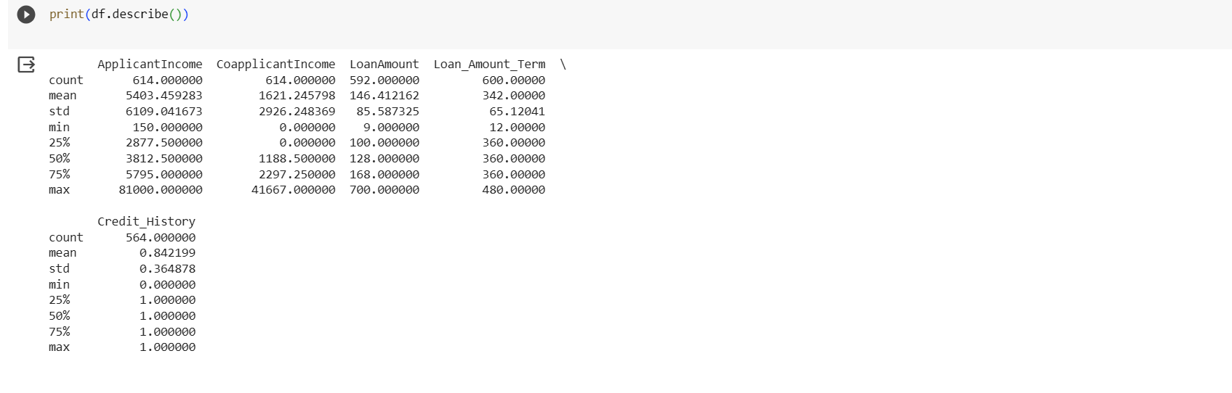
Fig 5.1.1 Data set
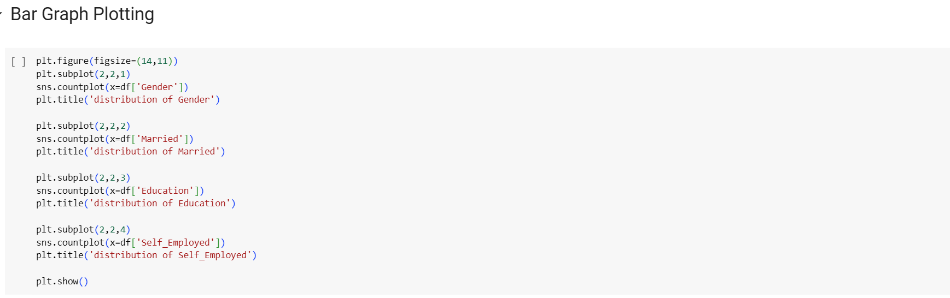
Fig 5.1.2 Bar plot
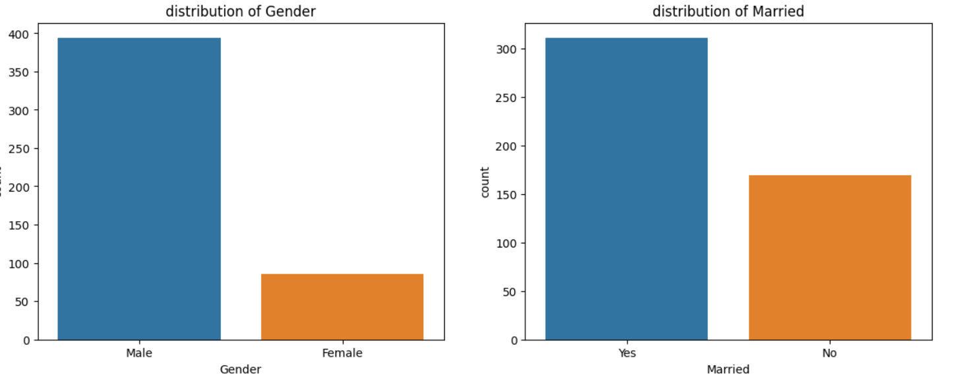
Fig 5.1.3 bar diagram
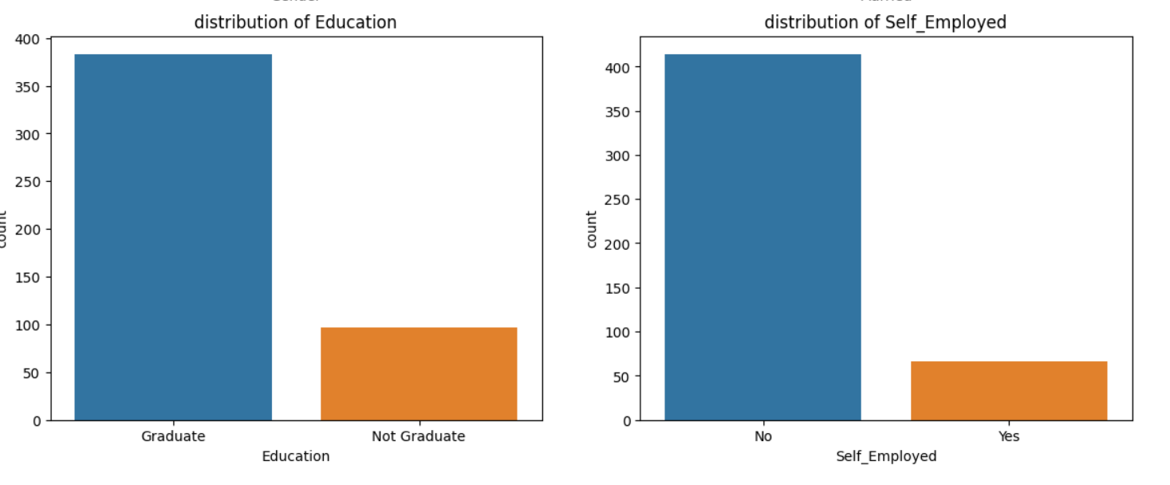
Fig 5.1.4 bar diagram

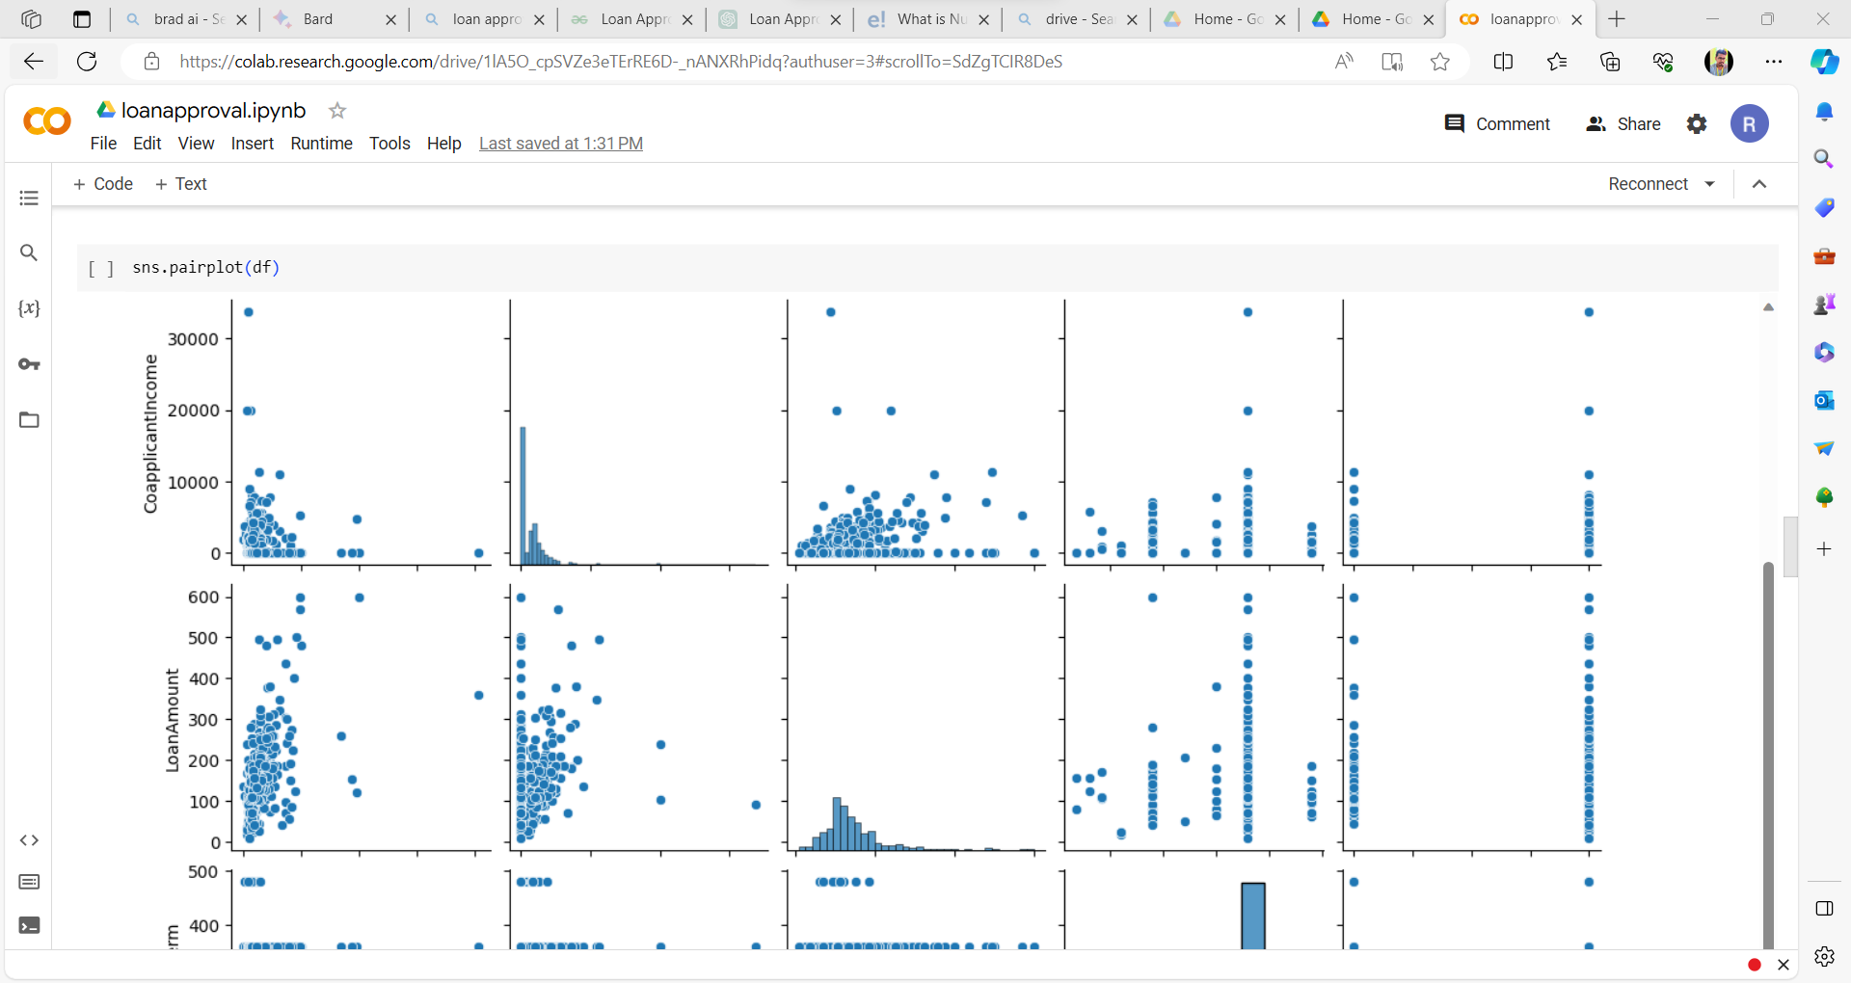
Fig 5.1.5 pair ploting
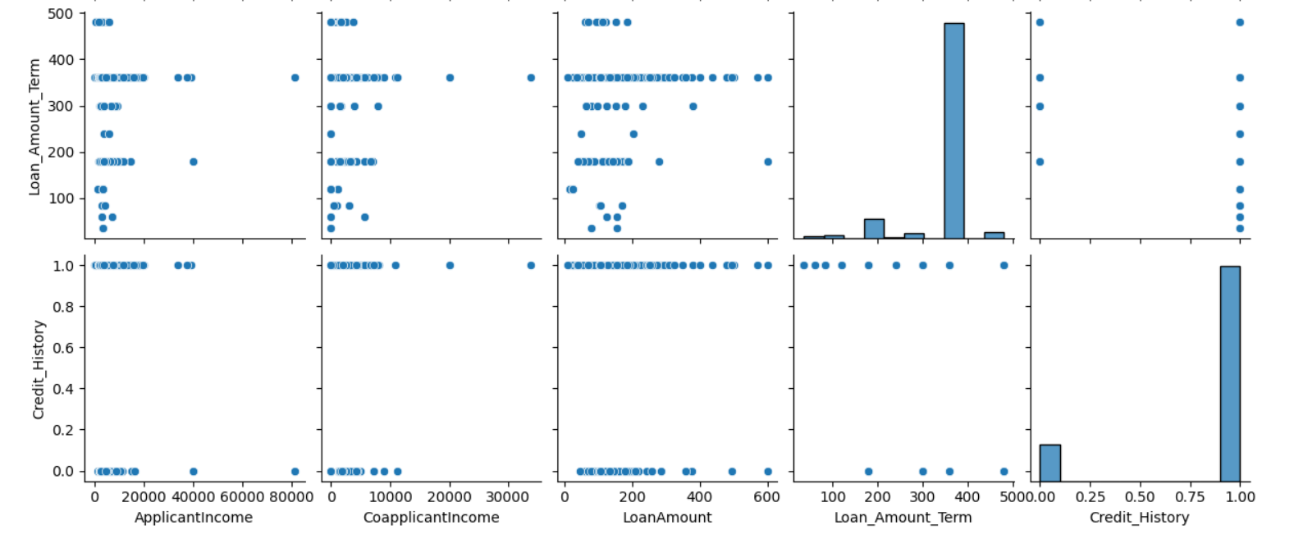
Fig 5.1.6 pair ploting
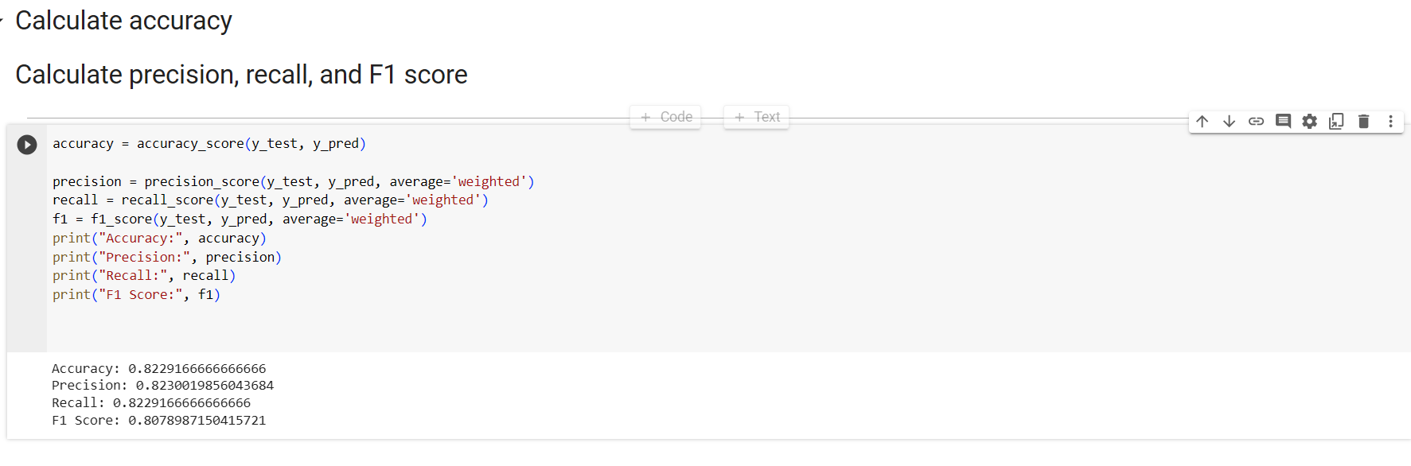
Fig 5.1.7 .Accurarcy
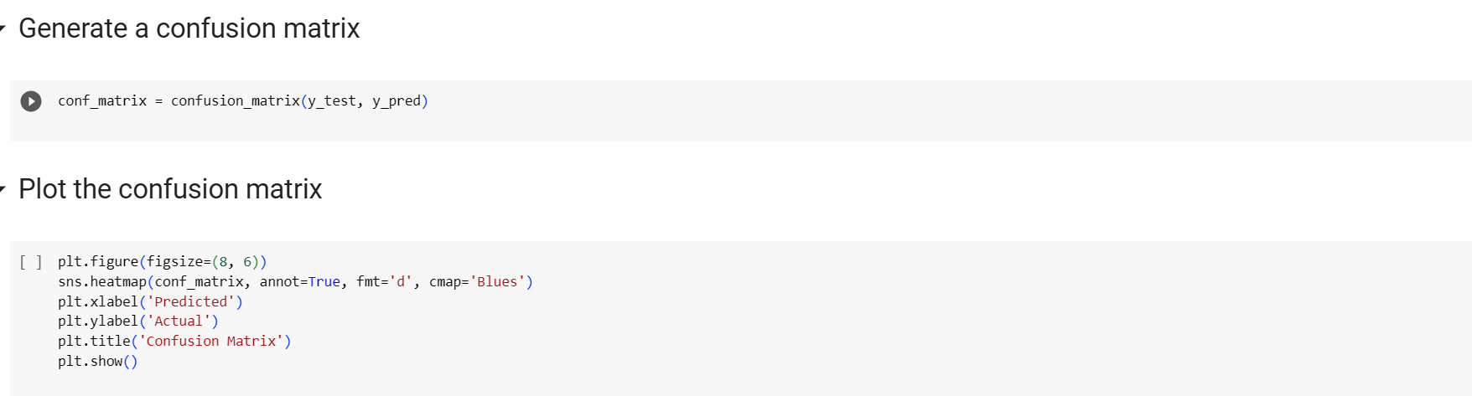
Fig 5.1.8 Confusion matrix
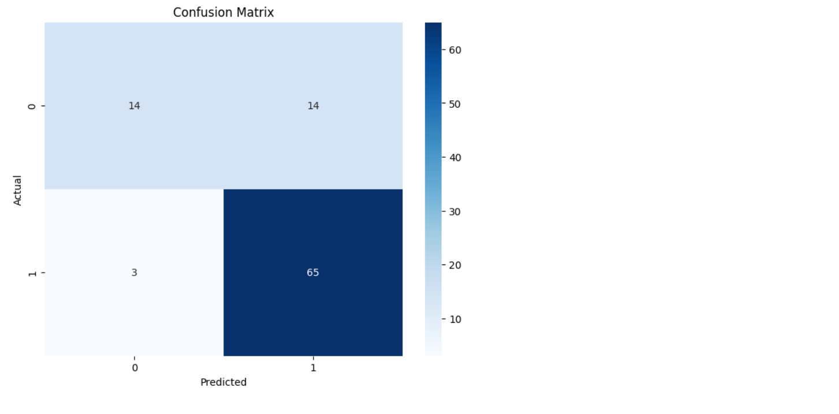
Fig 5.1.9. Matirx
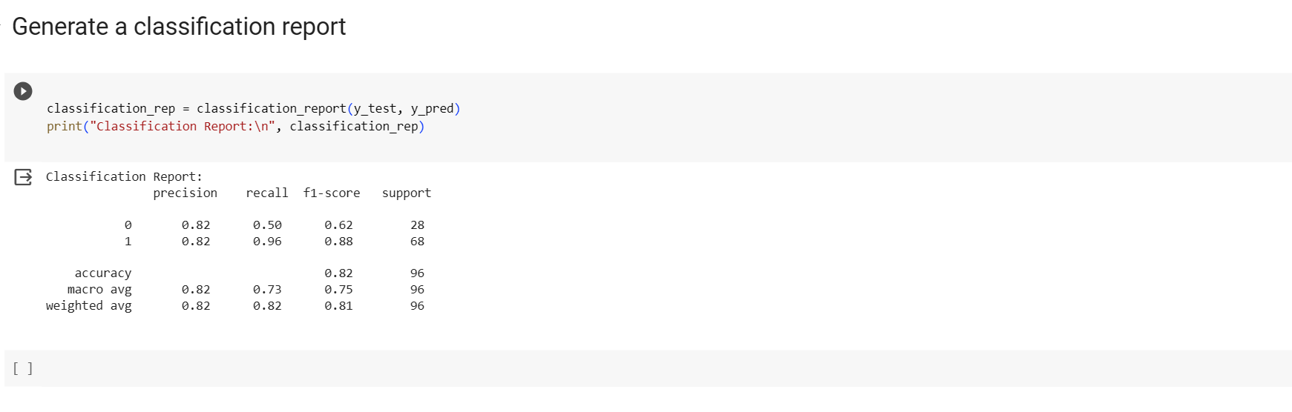
Fig 5.1.10 Report
CHAPTER -6
CONCLUSION
Lately people depend on bank loans to meet their wishes. The fee of loan packages will increase with a rapid speed in current years. There is need of automation of this system so that loan approval is much less risky.
In this project some ML algorithms like Random Forest, Support Vector Machine, etc. are implemented to expect the loan approval for customers. We further formulated a predictive model using Linear Regression that composed of the most important features for predicting customers credit worthiness. We’ve gone through a good portion of the data science in this project namely EDA and Modelling.
As it certainly a very important procedure for a bank to check whether an applicant, applying for a term loan should be approved or not. This project mainly focuses on making the tedious task mechanized. All the required algorithms were implemented successfully and accurate results were generated.
As ML techniques continue to evolve, their impact on loan approval prediction is poised to grow even further, shaping the future of lending practices and financial decision-making. By embracing ML with a focus on data quality, explainability, fairness, and continuous improvement, financial institutions can reap the benefits of this powerful technology while ensuring responsible and ethical lending practices.
The provided classification report presents the performance metrics for a classification model with two classes (0 and 1). Let's break down the key metrics:
Precision:
  - For class 0, precision is 0.820.82, indicating that 82%82% of the instances predicted as class 0 are actually class 0.
  - For class 1, precision is 0.820.82, indicating that 82%82% of the instances predicted as class 1 are actually class 1.
Recall (Sensitivity):
  - For class 0, recall is 0.500.50, indicating that 50%50% of the actual instances of class 0 were correctly predicted.
  - For class 1, recall is 0.960.96, indicating that 96%96% of the actual instances of class 1 were correctly predicted.
F1-score:
  - The F1-score is the harmonic mean of precision and recall.
  - For class 0, F1-score is 0.620.62.
  - For class 1, F1-score is 0.880.88.
Support:
  - Support is the number of actual occurrences of each class in the dataset.
  - For class 0, there are 28 instances.
  - For class 1, there are 68 instances.
Accuracy:
  - Overall accuracy is 0.820.82 or 82%82%, meaning that 82%82% of the predictions are correct.
Macro Average:
  - The macro average is the average of precision, recall, and F1-score across all classes.
  - The macro average precision is 0.820.82, recall is 0.730.73, and F1-score is 0.750.75.
Weighted Average:
  - The weighted average is the average of precision, recall, and F1-score, weighted by the number of instances in each class.
  - The weighted average precision is 0.820.82, recall is 0.820.82, and F1-score is 0.810.81.
In summary, the classification report provides a detailed overview of how well the model performs for each class and overall. In this case, the model seems to have high precision and recall for class 1, but lower values for class 0. Depending on the specific goals of your application, you might want to further investigate or fine-tune the model, especially if both precision and recall are crucial for both classes

In conclusion, machine learning algorithms, such as Logistic regression and Adaboost classifier,
show promising results for modern loan approval prediction. These models can automate the
decision-making process, improve efficiency, and reduce human bias. However, it is important to
continuously monitor and update these models with new data to maintain their accuracy and
relevance in dynamic financial environment
In conclusion, machine learning algorithms, such as Logistic regression and Adaboost classifier,
show promising results for modern loan approval prediction. These models can automate the
decision-making process, improve efficiency, and reduce human bias. However, it is important to
continuously monitor and update these models with new data to maintain their accuracy and
relevance in dynamic financial environment

CHAPTER-7
BIBLIOGRAPHY
[1] Pidikiti Supriya, Myneedi Pavani, Nagarapu Saisushma, Namburi Vimala Kumari, kVikash,“Loan Prediction by using Machine Learning Models”, InternationalJournalofEngineering andTechniques.Volume 5 Issue 2, Mar-Apr 2019.
[2] Nikhil Madane, Siddharth Nanda,”Loan Prediction using Decision tree”, Journal of the Gujrat Research History, Volume 21 Issue 14s, December 2019.
[3] S. Vimala, K.C. Sharmili, ―Prediction of Loan Risk using NB and Support Vector Machine‖, International Conference on Advancements in Computing Technologies (ICACT 2018), vol. 4, no. 2, pp. 110-113, 2018.
[4] Aboobyda Jafar Hamid and Tarig Mohammed Ahmed, ―Developing Prediction Model of Loan Risk in Banks using Data Mining‖, Machine Learning and Applications: An International Journal (MLAIJ), Vol.3, No.1, pp. 1-9, March 2016.
[5] Kumar Arun, Garg Ishan, Kaur Sanmeet, ―Loan Approval Prediction based on Machine Learning Approach‖, IOSR Journal of Computer Engineering (IOSRJCE), Vol. 18, Issue 3, pp. 79-81, Ver. I (May-Jun. 2016)
Loan Approval Predictor using Data Science and Machine Learning by Shail Vatsal Vashist (161480). Under the supervision of Dr. Aman Sharma, Jaypee University of Information Technology Waknaghat, Solan-173234, Himachal Pradesh.
Loan Default Prediction using Supervised Machine Learning Algorithms by Daria Granstrom. Under the supervision of Johan Abrahamsson, KTH Royal Institute of Technology School of Engineering Sciences, Stockholm, Sweden- 2019.
Predict Loan Approval in Banking System Machine Learning Approach for Cooperative Banks Loan Approval by Amrutha S. Aphale, Dr. Sandeep R. Shinde. Paper ID: IJERTV9IS080309, Volume & Issue: Volume 09, issue 08 (August2020), Publisher Name: IJERT.

Predict Loan Approval in Banking System Machine Learning Approach for Cooperative Banks Loan Approval by Amrutha S. Aphale, Dr. Sandeep R. Shinde. Paper ID: IJERTV9IS080309, Volume & Issue: Volume 09, issue 08 (August 2020), Publisher Name: IJERT.

